**Lab Exercise - 1**

* AIM ::

WAP in C++ to implement Bubble, Merge, Quick & Insertion Sort and also evaluate time in each.

**1. Bubble Sort**

Source_Code ::

### #include <ctime>

### #include <iostream>

### #include <vector>

### using namespace std;

### void bubbleSort(vector<int>& arr)

### {

### int n = arr.size();

### for (int i = 0; i < n - 1; i++) {

### for (int j = 0; j < n - i - 1; j++) {

### if (arr[j] > arr[j + 1]) {

### swap(arr[j], arr[j + 1]);

### }

### }

### }

### }

### int main()

### {

### cout << "5C6 - Amit Singhal (11614802722)" << endl;

### vector<int> arr = { 64, 34, 25, 12, 22, 11, 90 };

### cout << "Unsorted Array: ";

### for (int num : arr) {

### cout << num << " ";

### }

### cout << endl;

### clock_t start = clock();

### bubbleSort(arr);

### clock_t end = clock();

### cout << "Bubble Sort:" << endl;

### cout << "Sorted Array: ";

### for (int num : arr) {

### cout << num << " ";

### }

### cout << endl;

### double time_taken_ms = double(end - start) * 1000.0

### / CLOCKS_PER_SEC; // Convert to milliseconds

### cout << "Time taken: " << time_taken_ms << " milliseconds" << endl;

### return 0;

### }

### 

Output ::

**2. Merge Sort**

Source_Code ::

### #include <ctime>

### #include <iostream>

### #include <vector>

### using namespace std;

### void merge(vector<int>& arr, int l, int m, int r)

### {

### int n1 = m - l + 1;

### int n2 = r - m;

### vector<int> L(n1), R(n2);

### for (int i = 0; i < n1; i++)

### L[i] = arr[l + i];

### for (int i = 0; i < n2; i++)

### R[i] = arr[m + 1 + i];

### int i = 0, j = 0, k = l;

### while (i < n1 && j < n2) {

### if (L[i] <= R[j]) {

### arr[k] = L[i];

### i++;

### } else {

### arr[k] = R[j];

### j++;

### }

### k++;

### }

### while (i < n1) {

### arr[k] = L[i];

### i++;

### k++;

### }

### while (j < n2) {

### arr[k] = R[j];

### j++;

### k++;

### }

### }

### void mergeSort(vector<int>& arr, int l, int r)

### {

### if (l < r) {

### int m = l + (r - l) / 2;

### mergeSort(arr, l, m);

### mergeSort(arr, m + 1, r);

### merge(arr, l, m, r);

### }

### }

### int main()

### {

### cout << "5C6 - Amit Singhal (11614802722)" << endl;

### vector<int> arr = { 64, 34, 25, 12, 22, 11, 90 };

### cout << "Unsorted Array: ";

### for (int num : arr) {

### cout << num << " ";

### }

### cout << endl;

### clock_t start = clock();

### mergeSort(arr, 0, arr.size() - 1);

### clock_t end = clock();

### cout << "Merge Sort:" << endl;

### cout << "Sorted Array: ";

### for (int num : arr) {

### cout << num << " ";

### }

### cout << endl;

### double time_taken_ms = double(end - start) * 1000.0

### / CLOCKS_PER_SEC; // Convert to milliseconds

### cout << "Time taken: " << time_taken_ms << " milliseconds" << endl;

### return 0;

### }

Output ::

### 

**3. Quick Sort**

Source_Code ::

### #include <ctime>

### #include <iostream>

### #include <vector>

### using namespace std;

### int partition(vector<int>& arr, int low, int high)

### {

### int pivot = arr[high];

### int i = (low - 1);

### for (int j = low; j <= high - 1; j++) {

### if (arr[j] < pivot) {

### i++;

### swap(arr[i], arr[j]);

### }

### }

### swap(arr[i + 1], arr[high]);

### return (i + 1);

### }

### void quickSort(vector<int>& arr, int low, int high)

### {

### if (low < high) {

### int pi = partition(arr, low, high);

### quickSort(arr, low, pi - 1);

### quickSort(arr, pi + 1, high);

### }

### }

### int main()

### {

### cout << "5C6 - Amit Singhal (11614802722)" << endl;

### vector<int> arr = { 64, 34, 25, 12, 22, 11, 90 };

### cout << "Unsorted Array: ";

### for (int num : arr) {

### cout << num << " ";

### }

### cout << endl;

### clock_t start = clock();

### quickSort(arr, 0, arr.size() - 1);

### clock_t end = clock();

### cout << "Quick Sort:" << endl;

### cout << "Sorted Array: ";

### for (int num : arr) {

### cout << num << " ";

### }

### cout << endl;

### double time_taken_ms = double(end - start) * 1000.0

### / CLOCKS_PER_SEC; // Convert to milliseconds

### cout << "Time taken: " << time_taken_ms << " milliseconds" << endl;

### return 0;

### }

### 

Output ::

**4. Insertion Sort**

Source_Code ::

### #include <ctime>

### #include <iostream>

### #include <vector>

### using namespace std;

### void insertionSort(vector<int>& arr)

### {

### int n = arr.size();

### for (int i = 1; i < n; i++) {

### int key = arr[i];

### int j = i - 1;

### while (j >= 0 && arr[j] > key) {

### arr[j + 1] = arr[j];

### j = j - 1;

### }

### arr[j + 1] = key;

### }

### }

### int main()

### {

### cout << "5C6 - Amit Singhal (11614802722)" << endl;

### vector<int> arr = { 64, 34, 25, 12, 22, 11, 90 };

### cout << "Unsorted Array: ";

### for (int num : arr) {

### cout << num << " ";

### }

### cout << endl;

### clock_t start = clock();

### insertionSort(arr);

### clock_t end = clock();

### cout << "Insertion Sort:" << endl;

### cout << "Sorted Array: ";

### for (int num : arr) {

### cout << num << " ";

### }

### cout << endl;

### double time_taken_ms = double(end - start) * 1000.0

### / CLOCKS_PER_SEC; // Convert to milliseconds

### cout << "Time taken: " << time_taken_ms << " milliseconds" << endl;

### return 0;

### }

### 

Output ::

Output ::

**Lab Exercise - 2**

* AIM ::

WAP in C++ to implement Linear & Binary Search and also evaluate time in each.

**1. Linear Search**

### #include <ctime>

Source_Code ::

### #include <iostream>

### #include <vector>

### using namespace std;

### int linearSearch(const vector<int>& arr, int x)

### {

### for (int i = 0; i < arr.size(); i++) {

### if (arr[i] == x) {

### return i;

### }

### }

### return -1; // Element not found

### }

### int main()

### {

### cout << "5C6 - Amit Singhal (11614802722)" << endl;

### vector<int> arr = { 64, 34, 25, 12, 22, 11, 90 };

### cout << "Array: ";

### for (int num : arr) {

### cout << num << " ";

### }

### cout << endl;

### int x;

### cout << "Enter the element to search: ";

### cin >> x;

### clock_t start = clock();

### int index = linearSearch(arr, x);

### clock_t end = clock();

### if (index != -1) {

### cout << "Element found at index: " << index << endl;

### } else {

### cout << "Element not found" << endl;

### }

### double time_taken_ms = double(end - start) * 1000.0

### / CLOCKS_PER_SEC; // Convert to milliseconds

### cout << "Time taken: " << time_taken_ms << " milliseconds" << endl;

### return 0;

### }

Output ::

### 

**2. Binary Search**

### #include <algorithm>

Source_Code ::

### #include <ctime>

### #include <iostream>

### #include <vector>

### using namespace std;

### int binarySearch(const vector<int>& arr, int x)

### {

### int left = 0, right = arr.size() - 1;

### while (left <= right) {

### int mid = left + (right - left) / 2;

### if (arr[mid] == x) {

### return mid;

### }

### if (arr[mid] < x) {

### left = mid + 1;

### } else {

### right = mid - 1;

### }

### }

### return -1; // Element not found

### }

### int main()

### {

### cout << "5C6 - Amit Singhal (11614802722)" << endl;

### vector<int> arr = { 64, 34, 25, 12, 22, 11, 90 };

### sort(arr.begin(), arr.end()); // Binary search requires a sorted array

### cout << "Array: ";

### for (int num : arr) {

### cout << num << " ";

### }

### cout << endl;

### int x;

### cout << "Enter the element to search: ";

### cin >> x;

### clock_t start = clock();

### int index = binarySearch(arr, x);

### clock_t end = clock();

### if (index != -1) {

### cout << "Element found at index: " << index << endl;

### } else {

### cout << "Element not found" << endl;

### }

### double time_taken_ms = double(end - start) * 1000.0

### / CLOCKS_PER_SEC; // Convert to milliseconds

### cout << "Time taken: " << time_taken_ms << " milliseconds" << endl;

### return 0;

### }

Output ::

### 

**Lab Exercise - 3**

* AIM ::

WAP in C++ to implement Huffman Coding & also evaluate its time complexity.

#include <ctime>

Source_Code ::

#include <iomanip>

#include <iostream>

#include <queue>

#include <unordered_map>

#include <vector>

using namespace std;

// Node of Huffman Tree

struct Node {

char ch;

int freq;

Node *left, *right;

Node(char ch, int freq, Node* left = nullptr, Node* right = nullptr)

{

this->ch = ch;

this->freq = freq;

this->left = left;

this->right = right;

}

};

// Comparison function for priority queue

struct compare {

bool operator()(Node* left, Node* right)

{

return left->freq > right->freq;

}

};

// Function to build the Huffman Tree

Node* buildHuffmanTree(const unordered_map<char, int>& freq)

{

priority_queue<Node*, vector<Node*>, compare> pq;

for (auto pair : freq) {

pq.push(new Node(pair.first, pair.second));

}

while (pq.size() != 1) {

Node* left = pq.top();

pq.pop();

Node* right = pq.top();

pq.pop();

int sum = left->freq + right->freq;

pq.push(new Node('\0', sum, left, right));

}

return pq.top();

}

// Function to encode the input string

void encode(

Node* root, const string& str, unordered_map<char, string>& huffmanCode)

{

if (root == nullptr)

return;

if (!root->left && !root->right) {

huffmanCode[root->ch] = str;

}

encode(root->left, str + "0", huffmanCode);

encode(root->right, str + "1", huffmanCode);

}

// Function to decode the encoded string

string decode(Node* root, const string& str)

{

string result = "";

Node* curr = root;

for (char bit : str) {

if (bit == '0') {

curr = curr->left;

} else {

curr = curr->right;

}

if (!curr->left && !curr->right) {

result += curr->ch;

curr = root;

}

}

return result;

}

int main()

{

cout << "\n5C6 - Amit Singhal (11614802722)" << endl;

string text;

cout << "\nEnter the text to encode: ";

getline(cin, text);

unordered_map<char, int> freq;

for (char ch : text) {

freq[ch]++;

}

clock_t start = clock();

Node* root = buildHuffmanTree(freq);

clock_t end = clock();

double time_taken_build_tree

= double(end - start) * 1000.0 / CLOCKS_PER_SEC;

unordered_map<char, string> huffmanCode;

start = clock();

encode(root, "", huffmanCode);

end = clock();

double time_taken_encoding = double(end - start) * 1000.0 / CLOCKS_PER_SEC;

cout << "\nCharacter Encoding Table:" << endl;

cout << "------------------------------" << endl;

cout << setw(10) << "Character" << setw(20) << "Huffman Code" << endl;

cout << "------------------------------" << endl;

for (auto pair : huffmanCode) {

cout << setw(10) << pair.first << setw(20) << pair.second << endl;

}

cout << "------------------------------" << endl;

cout << "Time taken to build Huffman Tree: " << time_taken_build_tree

<< " milliseconds" << endl;

string encodedString = "";

for (char ch : text) {

encodedString += huffmanCode[ch];

}

cout << "\nEncoded String: " << encodedString << endl;

cout << "Time taken for encoding: " << time_taken_encoding

<< " milliseconds" << endl;

start = clock();

string decodedString = decode(root, encodedString);

end = clock();

double time_taken_decoding = double(end - start) * 1000.0 / CLOCKS_PER_SEC;

cout << "\nDecoded String: " << decodedString << endl;

cout << "Time taken for decoding: " << time_taken_decoding

<< " milliseconds" << endl;

return 0;

}

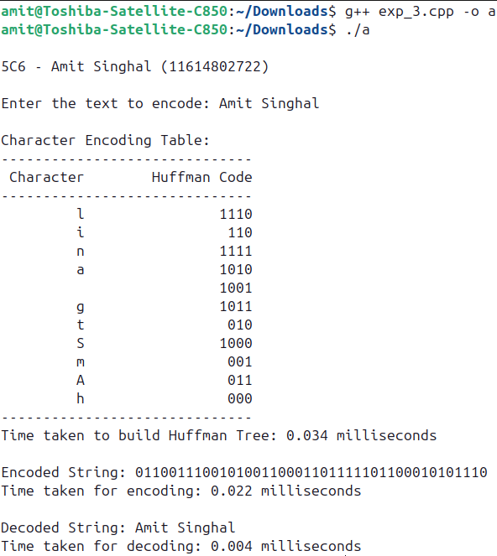

Output ::

**Lab Exercise - 4**

* AIM ::

WAP in C++ to find Minimum Spanning Tree for a Graph & also evaluate its time complexity.

Source_Code ::

#include <chrono>

#include <climits>

#include <iomanip>

#include <iostream>

#include <vector>

using namespace std;

using namespace std::chrono;

struct Edge {

int src, dest, weight;

};

// Function to display the graph in a table format

void displayGraph(int V, const vector<Edge>& edges)

{

cout << "Original Graph:\n";

cout << setw(10) << left << "Edges" << setw(10) << left << "Weights"

<< endl;

cout << "-----------------" << endl;

for (const auto& edge : edges) {

cout << setw(1) << edge.src << " - " << setw(8) << edge.dest << setw(10)

<< edge.weight << endl;

}

}

// Function to convert edge list to adjacency matrix

vector<vector<int>> toAdjacencyMatrix(int V, const vector<Edge>& edges)

{

vector<vector<int>> adjMatrix(V, vector<int>(V, 0));

for (const auto& edge : edges) {

adjMatrix[edge.src][edge.dest] = edge.weight;

adjMatrix[edge.dest][edge.src]

= edge.weight; // Since the graph is undirected

}

return adjMatrix;

}

// Function to find the vertex with the minimum key value

int minKey(const vector<int>& key, const vector<bool>& inMST)

{

int min = INT_MAX, min_index;

for (int v = 0; v < key.size(); ++v) {

if (!inMST[v] && key[v] < min) {

min = key[v];

min_index = v;

}

}

return min_index;

}

// Function to implement Prim's algorithm to find the MST

void primMST(int V, const vector<vector<int>>& graph)

{

vector<int> parent(V, -1); // Array to store constructed MST

vector<int> key(V, INT_MAX); // Key values to pick minimum weight edge

vector<bool> inMST(

V, false); // To represent vertices not yet included in MST

key[0] = 0; // Start from the first vertex

for (int count = 0; count < V - 1; ++count) {

int u = minKey(key, inMST);

inMST[u] = true;

for (int v = 0; v < V; ++v) {

if (graph[u][v] && !inMST[v] && graph[u][v] < key[v]) {

parent[v] = u;

key[v] = graph[u][v];

}

}

}

// Print the constructed MST

cout << "\nMinimum Spanning Tree (MST):\n";

cout << setw(10) << left << "Edges" << setw(10) << left << "Weights"

<< endl;

cout << "------------------" << endl;

for (int i = 1; i < V; ++i) {

cout << setw(1) << parent[i] << " - " << setw(8) << i << setw(10)

<< graph[i][parent[i]] << endl;

}

}

int main() {

cout << "\n5C6 - Amit Singhal (11614802722)\n" << endl;

int V = 4; // Number of vertices in the graph

vector<Edge> edges = { { 0, 1, 7 }, { 0, 2, 9 }, { 0, 3, 14 },

{ 1, 2, 10 }, { 1, 3, 15 }, { 2, 3, 11 } };

displayGraph(V, edges);

// Convert edge list to adjacency matrix

vector<vector<int>> adjMatrix = toAdjacencyMatrix(V, edges);

// Measure the time taken to find the MST

auto start = high_resolution_clock::now();

primMST(V, adjMatrix);

auto stop = high_resolution_clock::now();

auto duration = duration_cast<microseconds>(stop - start);

cout << "\nTime taken to find MST: " << duration.count()

<< " microseconds\n";

return 0;

}

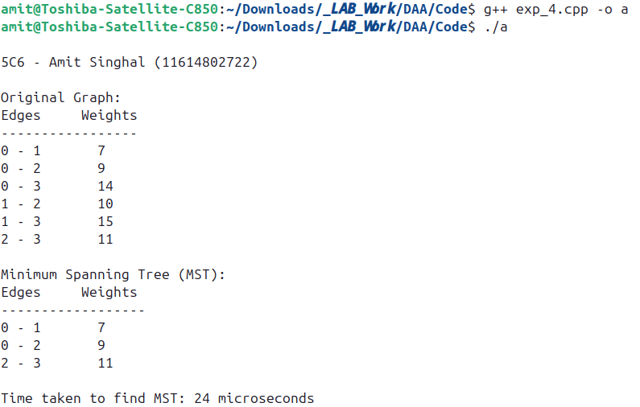

Output ::

**Lab Exercise - 5**

* AIM ::

WAP in C++ to implement Dijsktra’s Algorithm & also calculate time complexity to find the shortest path

Source_Code ::

#include <chrono>

#include <climits>

#include <iostream>

#include <queue>

#include <vector>

using namespace std;

using namespace std::chrono;

// Structure to represent an edge in the graph

struct Edge {

int to;

int weight;

};

// Function to add an edge to the adjacency list

void addEdge(vector<vector<Edge> >& graph, int u, int v, int weight) {

graph[u].push_back({v, weight});

graph[v].push_back({u, weight}); // For undirected graph

}

// Function to display the graph

void displayGraph(const vector<vector<Edge> >& graph) {

cout << "Graph adjacency list representation:\n";

for (int i = 0; i < graph.size(); ++i) {

cout << "Node " << i << ": ";

for (const auto& edge : graph[i]) {

cout << "(to: " << edge.to << ", weight: " << edge.weight << ") ";

}

cout << endl;

}

}

// Dijkstra's algorithm implementation

vector<int> dijkstra(const vector<vector<Edge> >& graph,

int source,

int64_t& timeTaken) {

int n = graph.size();

vector<int> dist(n, INT_MAX); // Distance array, initialized to infinity

dist[source] = 0; // Distance to source is 0

// Priority queue to store {distance, node}

priority_queue<pair<int, int>, vector<pair<int, int> >,

greater<pair<int, int> > >

pq;

pq.push({0, source});

// Measure time start

auto start = high_resolution_clock::now();

while (!pq.empty()) {

int u = pq.top().second; // Get the node with the smallest distance

int d = pq.top().first; // Get the distance of that node

pq.pop();

// If the distance in the queue is greater than the already found

// shortest distance, skip

if (d > dist[u])

continue;

// Explore the neighbors of node u

for (const auto& edge : graph[u]) {

int v = edge.to;

int weight = edge.weight;

// Relaxation step

if (dist[u] + weight < dist[v]) {

dist[v] = dist[u] + weight;

pq.push({dist[v], v});

}

}

}

// Measure time end

auto stop = high_resolution_clock::now();

auto duration = duration_cast<nanoseconds>(stop - start);

timeTaken = duration.count(); // Time in nanoseconds

return dist;

}

int main() {

cout << "\n5C6 - Amit Singhal (11614802722)\n" << endl;

int n, e, source;

// Input: Number of nodes and edges

cout << "Enter the number of nodes and edges: ";

cin >> n >> e;

vector<vector<Edge> > graph(n);

// Input: Edges

cout << "\nEnter the edges (u, v, weight):\n";

for (int i = 0; i < e; ++i) {

int u, v, weight;

cin >> u >> v >> weight;

addEdge(graph, u, v, weight);

}

cout << endl;

// Display the graph

displayGraph(graph);

// Input: Source node

cout << "\nEnter the source node: ";

cin >> source;

// Time taken for calculating the shortest paths

int64_t totalTime;

// Find shortest paths from the source node to all other nodes

vector<int> dist = dijkstra(graph, source, totalTime);

// Display shortest distances from the source to all other nodes

cout << "\nShortest distances from node " << source << " to all other nodes:\n";

for (int i = 0; i < dist.size(); ++i) {

if (dist[i] == INT_MAX) {

cout << "To node " << i << " : Unreachable\n";

} else {

cout << "To node " << i << " : " << dist[i] << endl;

}

}

// Display time complexity

cout << "\nTime taken to compute shortest paths from node " << source

<< ": " << totalTime << " nanoseconds" << endl;

return 0;

}

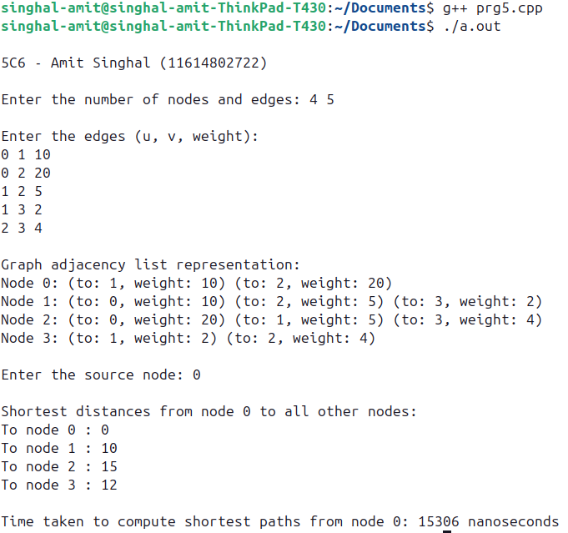

Output ::